Group 1:

Luu Duy Anh

Dinh Ngoc Hoa

Submission of Team Project: Library System

Main Menu:

To enter as a Guest, select option 2 to go into the guest menu:

To read a book as a guest, select option 2:

Enter a serial number of a book to read it:

Select Y or N to continue reading or to get the option to return to the guest menu (as above)

Select option 1 to go back to the guest menu:

Select option 3 to register membership:

Select option 1 to go back to the guest menu:

Select option 1 to go back to the main menu:

To login as an admin or a member, select option 1:

To login as an admin, select option 2:

If you enter the wrong username / password, there is an option to try again or to return to the previous menu:

Login successfully will lead you to menu for admins:

Select option 1 to add another admin:

Select Y or N to continue adding or to get the option to return to the admin menu (as above)

Select option 1 to go back to the admin menu:

Select option 2 to go to book settings:

Select option 1 to add books to library:

Select Y or N to continue adding or to get the option to return to the book settings menu (as above)

Select option 1 to go back to the book settings menu:

Select option 2 to change book’s status to be shown publicly in the library:

If you enter the wrong serial number of the book, there is an option to try again or to return to the previous menu:

Select Y or N to continue adding or to get the option to return to the book settings menu (as above)

Select option 1 to go back to the book settings menu:

Select option 3 to change book’s status to be hidden in the library:

If you enter the wrong serial number of the book, there is an option to try again or to return to the previous menu:

Select option 1 to go back to the book settings menu:

Select option 4 to remove book from the library:

If you enter the wrong serial number of the book, there is an option to try again or to return to the previous menu:

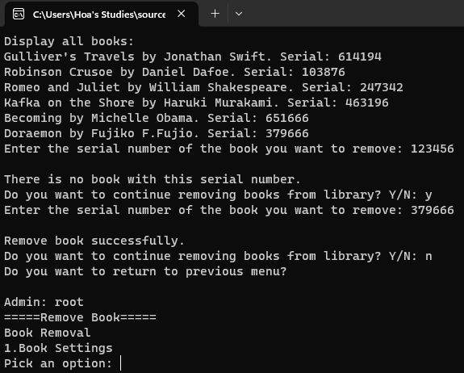

Select option 1 to go back to the book settings menu:

Select option 5 to display all books from the library:

Select option 1 to go back to the book settings menu:

Select option 6 to edit a book in the library:

If you enter the wrong serial number of the book, there is an option to try again or to return to the previous menu:

Select option 1 to go back to the book settings menu:

Select option 7 to go back to admin menu:

Select option 3 to go to collection settings:

Select option 1 to create a new collection:

Select option 1 to go back to the collection settings menu:

Select option 2 to remove an existed collection:

If you enter the wrong ID of the collection, there is an option to try again or to return to the previous menu:

Select option 1 to go back to the collection settings menu:

Select option 3 to edit existed collection:

If you enter the wrong ID of the collection, there is an option to try again or to return to the previous menu:

Select option 1 to go back to the collection settings menu:

Select option 4 to display all collections:

Select option 1 to go back to the collection settings menu:

Select option 5 to go back to admin menu:

Select option 4 to logout:

Select option 1 to go back to the main menu:

To login as an admin or a member, select option 1:

To login as an member, select option 3:

If you enter the wrong username / password, there is an option to try again or to return to the previous menu:

Login successfully will lead you to menu for members:

Select option 1 to read a book:

Select option 1 to go back to the member menu:

Select option 2 to borrow a book:

If you enter the wrong serial number of the book, there is an option to try again or to return to the previous menu:

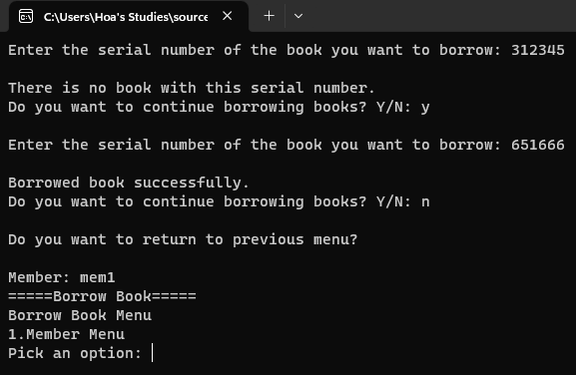

Select option 1 to go back to the member menu:

Select option 3 to return book:

Select option 1 to go back to the member menu:

Select option 4 to subscribe to a existed collection:

If you enter the wrong ID of the collection, there is an option to try again or to return to the previous menu:

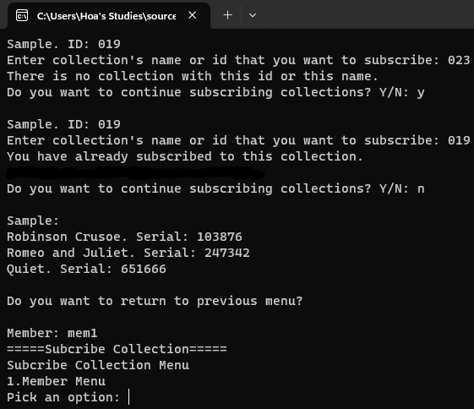

Select option 1 to go back to the member menu:

Select option 5 to unsubscribe a collection:

If you enter the wrong ID of the collection, there is an option to try again or to return to the previous menu:

Select option 1 to go back to the member menu:

Select option 6 to display all subscribed collection:

Select option 1 to go back to the member menu:

Select option 6 to display all borrowed books:

Select option 1 to go back to the member menu:

Select option 8 to logout:

Select option 1 to go back to the main menu:

Select option 3 to search for a bookby its title or serial number:

If you enter the wrong title or serial number of the book, there is an option to try again or to return to the previous menu:

Select option 1 to go back to the main menu:

Select option 4 to exit the program:

